PYTHON LAB EXERCISE

1. Write a Python program to print the calendar of a given month and year.

Note:

Take month and year input from the user

year in four digits format for example, 2003, 1997, 2018 etc.

month in digit format, for example 1 to 12.

If month and year are not in specified format display **Invalid Input**

AIM: Write a python program to print the calendar of a given month and year

PROGRAM:

import calendar as cal

year=int(input())

month=int(input())

if(year>999 and year<10000):

if(month>=1 and month<=12):

print(cal.month(year,month))

else:

print("Invalid Input")

else:

print("Invalid Input")

LINK: <http://103.53.53.18/mod/vpl/forms/submissionview.php?id=229&userid=1646>

OUTPUT:

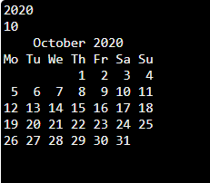

RESULT : Thus the python program is written the calendar of the month and year is printed

2) Given a list in Python and a number x, count number of occurrences of x in the given list.

Write a Python function **countX(lst, x)** to count the number x in a given list of numbers.

Note: Take input (total number of element in the list, list element and x) from the user and call the function **countX(lst, x)**

AIM: Given a list in python and a number x, count number of occurrences of x in thr given list.

PROGRAM:

def countX(lst,x):

count=0

for i in range(0,len(lst)):

if(x1==lst[i]):

count=count+1

return count

lst1=[]

n=int(input())

for i in range(0,n):

inp=int(input())

lst1.append(inp)

x1=int(input())

y=countX(lst1,x1)

LINK: <http://103.53.53.18/mod/vpl/forms/submissionview.php?id=230&userid=1646>

OUTPUT:



RESULT: Thus the given a list in Python and a number x, count number of occurrences of x in the given list is executive.

3) Write a Python program to remove and print every second number from a list of numbers until the list becomes empty.

Note:

* use function
* Take input (total number of element in the list, list element) from the user and call the function **removeThirdNumber(int_list)).**

AIM: Write a Python program to remove and print every second number from a list of numbers until the list becomes empty.

PROGRAM:

def removeThirdNumber(lst):

lst1=[]

pos=1

s=0

for i in range(0,len(lst)):

s=(pos+s)%len(lst)

e1=lst.pop(s)

lst1.append(e1)

return lst1

n=int(input())

int_list=[]

for i in range(0,n):

e=int(input())

int_list.append(e)

p=removeThirdNumber(int_list)

print(p)

LINK: <http://103.53.53.18/mod/vpl/forms/submissionview.php?id=231&userid=1646>

OUTPUT:

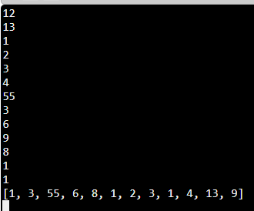

RESULT: Thus the given python program to remove and print every second number from a list of numbers until the list becomes empty is executive.

4) Write a Python program (function) to print a single string from two set of strings received from user and swap the first two characters of each string.

Input:

    Python

    Java

Output:

    jathon pyva

Note:

If length of any one of the string is less than 2 then print **Invalid**

**AIM:** Write a Python program (function) to print a single string from two set of strings received from user and swap the first two characters of each string.

**PROGRAM:**

def convert(s):

new=""

for x in s:

new+=x

return new

a=input()

b=input()

s1=a.strip()

s2=b.strip()

if(len(s1)>=2 and len(s2)>=2):

t1=list(s1)

t2=list(s2)

c1=t1[0]

c2=t1[1]

t1[0]=t2[0]

t1[1]=t2[1]

t2[0]=c1

t2[1]=c2

s1=convert(t1)

s2=convert(t2)

print(s1,"",s2)

else:

print("Invalid")

LINK: <http://103.53.53.18/mod/vpl/forms/submissionview.php?id=234&userid=1646>

OUTPUT:

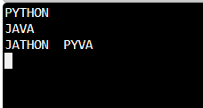

RESULT: Thus the given python program (function) to print a single string from two set of strings received from user and swap the first two characters of each string is executive.

5) A pangram is a sentence that contains all the alphabets at least once. For example,

“The quick brown fox jumps over the lazy dog”. This sentence contains all the alphabets from ‘a’ to ‘z’.

Write a Python function to print missing characters to make string pangram.

**Input Format:**

The first line of the input is a string most probably a sentence.

**Output Format:**

Print the alphabets that are missing in that string to make it a pangram.

**Sample Input:**

the quick brown fox jumps over the lazy

**Sample Output:**

dg

**Explanation:**The given string contains all the alphabets except ‘d’ and ‘g’. If those two alphabets are included then it would be a pangram. So, the output is “dg”.

AIM: Write a Python function to print missing characters to make string pangram.

PROGRAM:

a=input()

a=set(a.strip())

a.remove(chr(32))

b="abcdefghijklmnopqrstuvwxyz"

b=set(b)

b=b.difference(a)

b=list(b)

b.sort()

print("".join(b))

LINK: <http://103.53.53.18/mod/vpl/forms/submissionview.php?id=235&userid=1646>

OUTPUT:

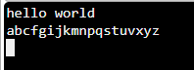

RESULT: Thus the given python function to print missing characters to make string pangram is executive.